**HDR brachytherapy needle autodetect workaround**

**Issue summary and cause:**

Since v16, the needle autodetect feature in brachytherapy planning has stopped working for NBR. Prior to v16, this feature worked fine in v15. The loss of this feature has resulted in mild annoyance for the physicists and delays in treatment due to the time required for manual needle digitization (~30+ mins for a typical prostate). The cause of this issue has to do with the interpretation of signed CT data by Aria. Our CT scanner (GE Lightspeed) records the reconstructed CT data (i.e., pixel values) at a bit depth of 16; however, this data is signed so the values range from -32768 to 32768. Keep in mind, this is the pixel data, not HU values. The pixel data is converted to HU using a first order polynomial with coefficients stored in the header file. Aria reads the pixel values and automatically performs the conversion from pixel value to HU.

Generally, the pixel data should be unsigned with a min value of 0. This is the case for our scanner INSIDE THE IMAGING FOV. Outside the FOV, it reports a generic pixel value of -2000. This is causing problems in v16 of Aria where it will correctly perform the conversion from pixel value to HU, but then it will set the HU intercept coefficient (usually around -1024 HU) as the minimum possible pixel value converted to HU (i.e., -2^15 + HU intercept coefficient 🡪 -32768 -1024 = -33792). Shown below is an example of this issue from a recent prostate patient CT scan (under contouring, right click on CT->properties->Tech(CT) tab):

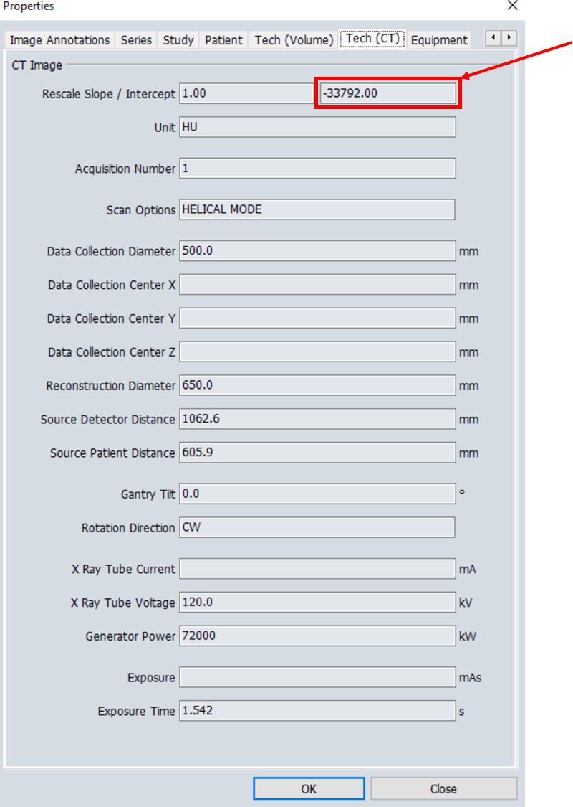

This misrepresentation of the HU intercept becomes a problem for the needle autodetect algorithm as it uses this intercept to set the minimum HU for thresholding to determine the needle locations. Shown below is an example of the autodetect options window for this patient:

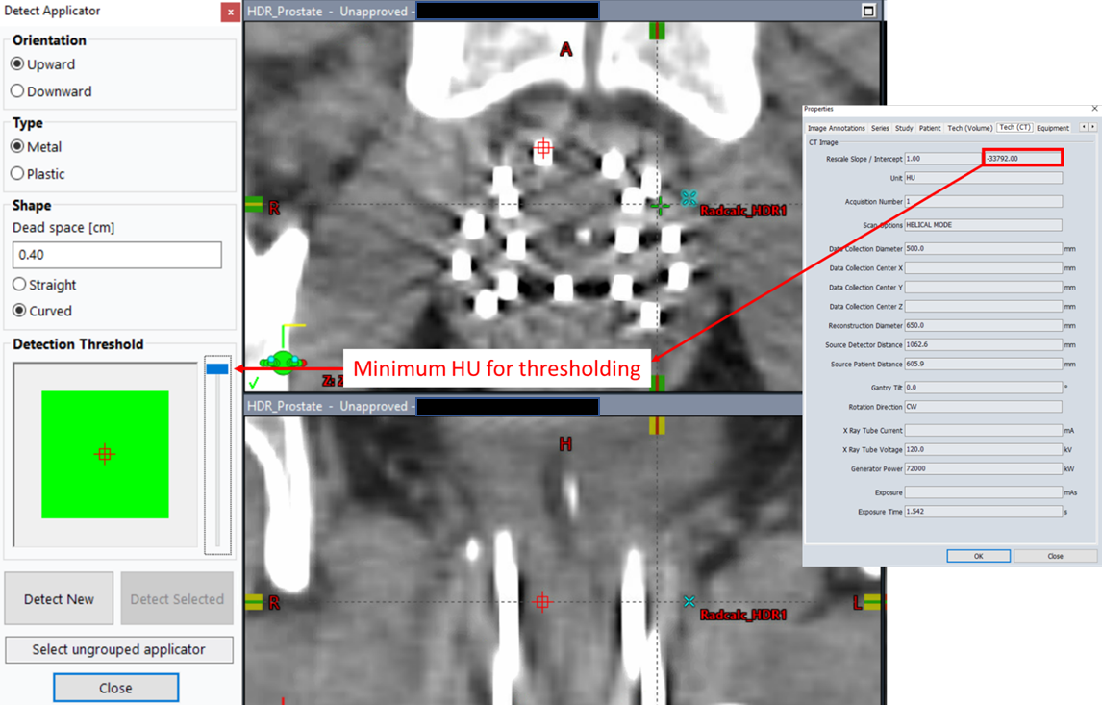

You’ll notice that as you move the slider bar in the above image (i.e., the min HU used to threshold the image), nothing happens. I’m guessing they developed the tool assuming a typical HU range would be encountered in the image (i.e., ~4000 HU total range). So, the maximum HU threshold would be the min + 4000 HU, which is an issue given -33792 HU + 4000 HU = -29792 HU << -1000 HU!!

The obvious solution to this issue is to correct the CT data so it reports unsigned pixel values. This can be performed by modifying the max bit and pixel representation DICOM elements in the header for each image slice (i.e., change max bit to 16 and set pixel representation to 0 to signal unsigned data). From my own testing, this had no impact on the issue and the HU intercept reported in Aria was still -33792 HU. From reaching out to Varian, here are their thoughts on the issue:

Varian does not recommend adjusting the max bit and pixel representation as this can result in weird HU values (because you are forcing a negative integer to be unsigned without modifying the value).

**Solution:**

The alternative to forcing the signed pixel values to behave as unsigned data is to modify every pixel value and adjust the HU intercept coefficient. Since the rescaling is linear, the pixel data can be offset by -2^15 and the intercept can be offset by +2^15. Upon rescaling the pixel values to HU, the HU values will be identical to original HU values except for the pixel values that were originally negative (as they are now less than -2^15, which is not allowed for a 16 bit depth). Shown below is the properties of a modified CT image:

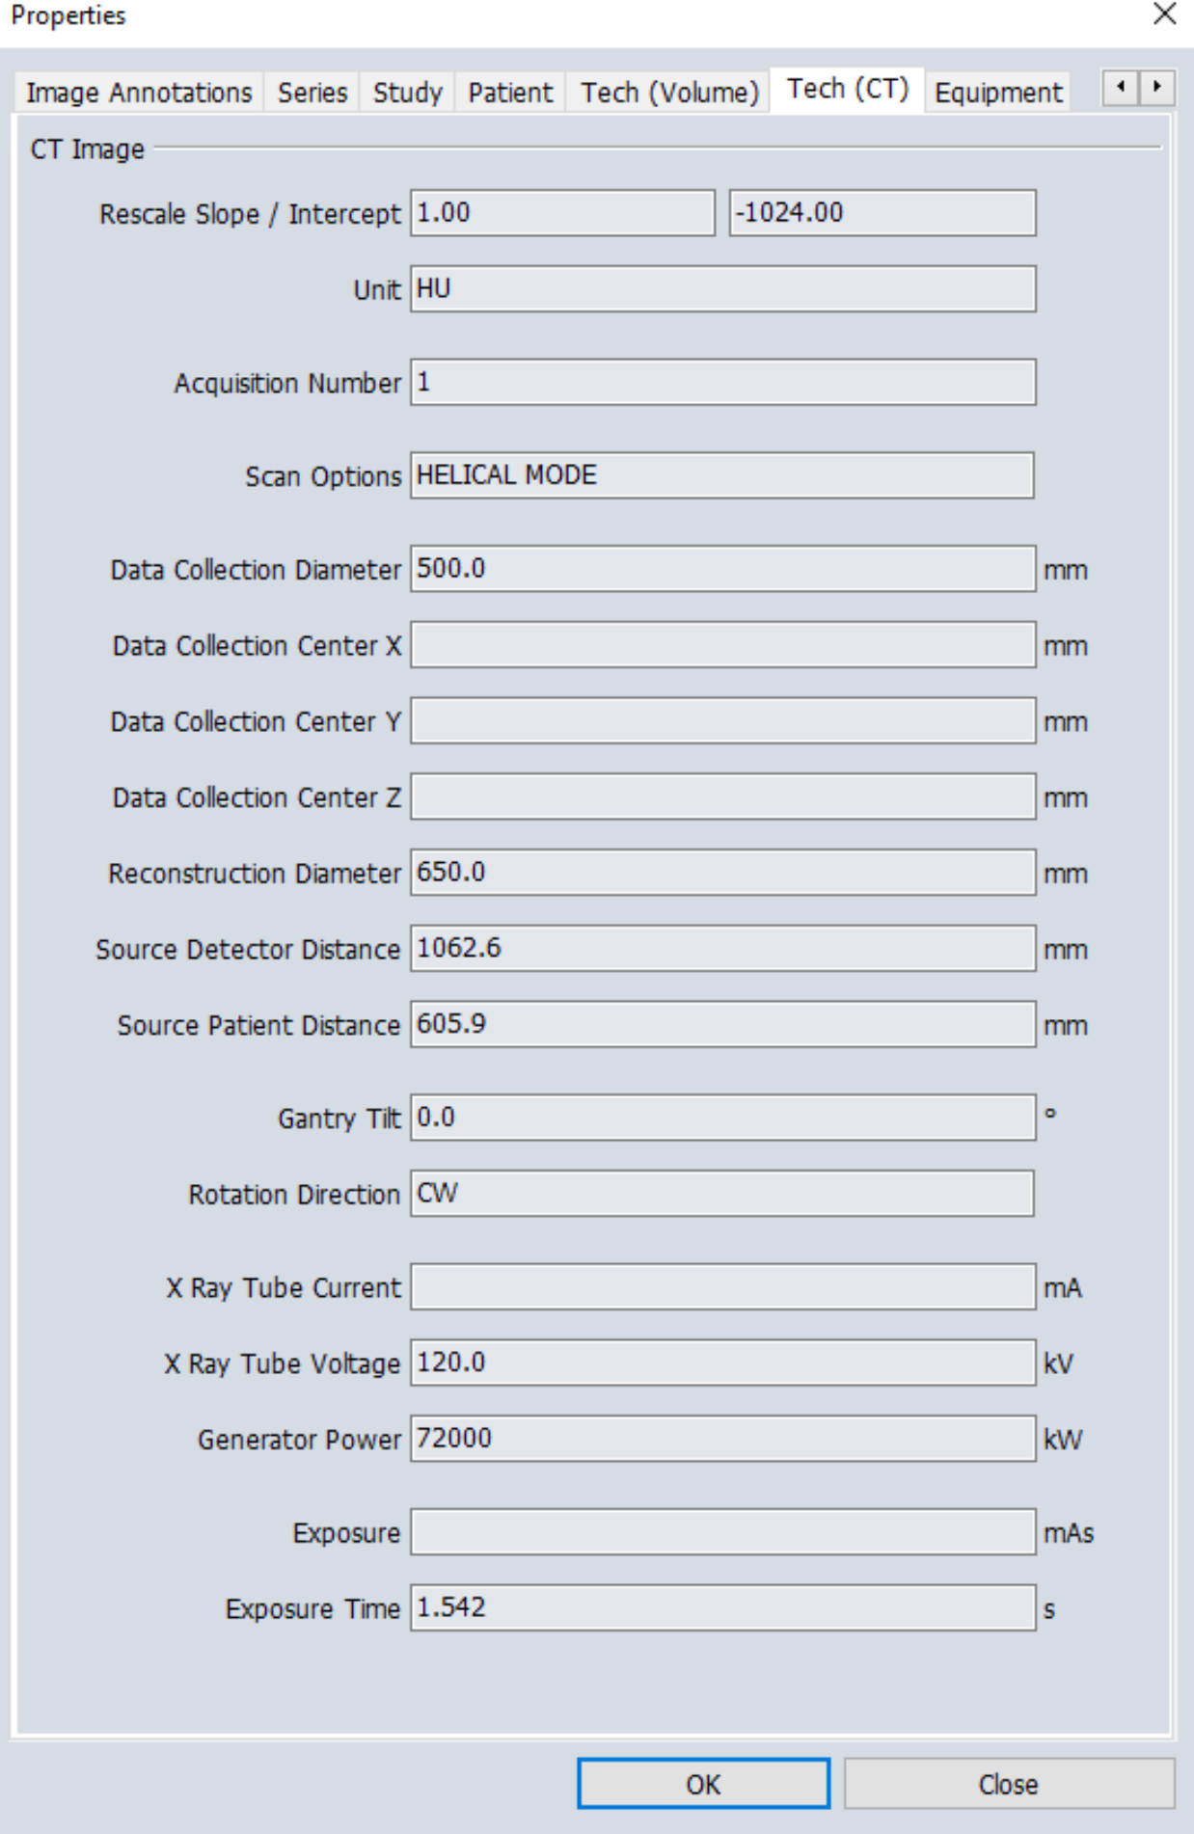

Shown below is the image difference between the original and modified CT image with 1 HU set as the minimum difference on the window (default max difference set on window):

As shown above, there is no difference inside the imaging FOV. There are significant differences outside the imaging FOV (i.e., where the negative pixel values originally were). But this region isn’t relevant for treatment planning (brachy or EBRT).

Using the modified CT, the autodetect tool now works (i.e., adjusting the thresholding bar now has an effect):

**Slow method (i.e., not recommended):**

Should we modify the CT data, we will want to import the original and the modified data to ensure that we are just correcting the data for this one issue and are not introducing artifacts into the image (which could impact contouring accuracy). To modify the CT data:

1. Import original CT into aria
2. Export the original CT data with an anonymization filter
   1. You will want to anonymize the data so the CT will show up as a different study. If not, the modified CT data will be assigned to the original CT data series, which means you will need to manually create a 3D image and determine which CT images in that series are original and which are modified
3. Use MATLAB to modify the data
4. Import the modified data
5. Register the modified CT data to the original CT data
   1. The images should match exactly without need for adjustment (since they share the same dicom origin)
   2. Use the image difference tool to ensure there are no HU differences between the two images
6. Have the physician contour on the original CT data and use the modifying data for planning and auto needle detection

**The above method will be slow since you have to import/export multiple times.**

**Recommended Method:**

The method I recommend is similar to the above method except the CT data modification is performed on a copy of the original CT data prior to import:

1. Run the program ‘fixCT’ and point the program at the directory containing the CT data of interest
   1. Launch the program located at:

\\<path to fixCT>\bin\fixCT.exe

* 1. Run the ESAPI script within brachytherapy planning. Brachytherapy planning🡪tools🡪scripts🡪select ‘Folder’🡪 navigate to:

\\<path to fixCT>\bin\

🡪 hit open 🡪 select ‘launchFixCT.cs’ 🡪 Run

1. Point the program at the folder containing the original CT data
2. Wait for the program to finish (it will tell you when it’s done)
3. Import the CT data using the import/export tool in Eclipse
   1. The modified data has placed inside a new folder created inside the original CT data location. This way you can import both datasets simultaneously
4. Rename both datasets, registered the images, verify there are no HU differences, and continue planning. Physician will contour on original image and physics will plan on modified image.